1. Splitting the models in to sub models
2. In source and extract file we need to take each select statement into sub models
3. Into Individual models
4. Intermediate (ephemeral) and load (table) and stage (view)

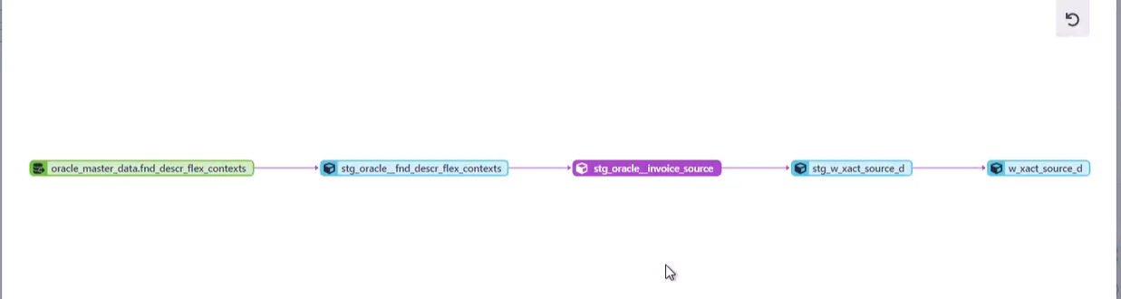

Question no.1

1. Why we are going for incremental in final? (if it is created in staging …itself snowflake cost optimization will be easy)
2. in .sql file (it is given as sub select statements , we have to convert each sub select statements into each model and we have to create final model from all the stg models using union.
3. Staging to intermediate to final (is it?)

**set** source = 'ORACLE_FINANCIALS';**select** b.table_catalog,b.table_schema,b.table_name,b.column_name,b.data_type,b.ordinal_position

**from** DEV_ODS.INFORMATION_SCHEMA.columns b

**where** b.table_schema = $source

AND B.TABLE_NAME IN ('AP_AE_LINES_ALL')**order** **by** b.table_name,b.ordinal_position;

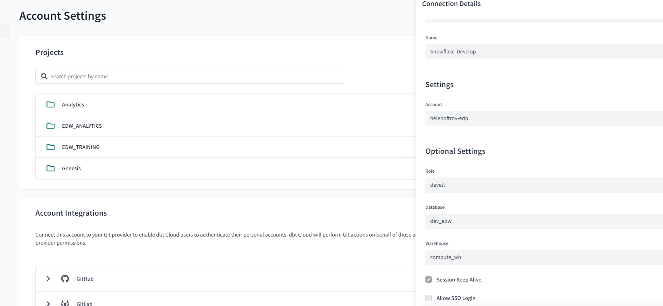

Schema : dbt_ashyam



COLUMN_NAME REPEAT

select table_schema,

table_name,

created as create_date,

last_altered as modify_date

from information_schema.tables

where table_name in ('HZ_CUST_ACCOUNTS','T_EP_E1_CUST_CAT_2','T_EP_LOB','T_EP_SITE','HZ_PARTIES','T_EP_EBS_ACCOUNT','LOCATION','HOTDEM2',

'HZ_CUSTOMER_PROFILES','AR_COLLECTORS','SQ_LOB_PARTITION','HZ_CUST_SITE_USES_ALL','GL_CODE_COMBINATIONS','HZ_CUST_ACCT_SITES_ALL','HZ_LOCATIONS','XLA_DISTRIBUTION_LINKS')

order by table_schema,

table_name

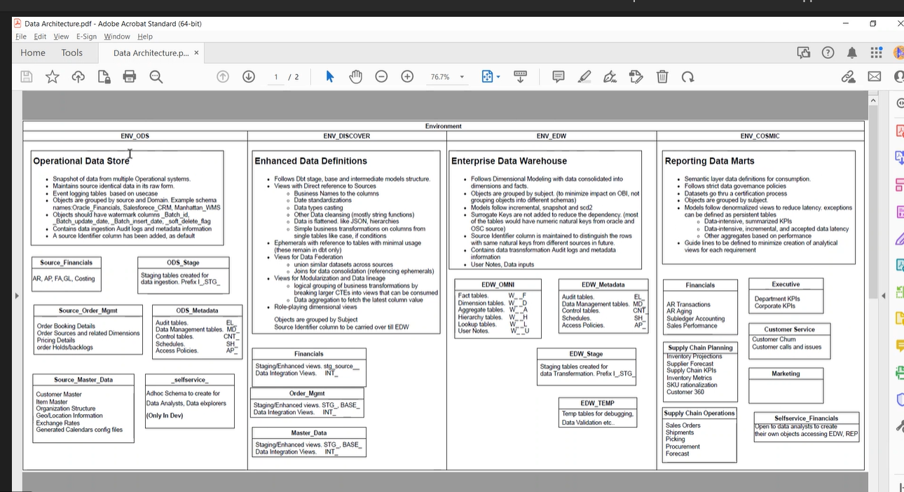

ODS (RAW)